Business Model:

**Introduction to Business Model**

A business model is the method of doing business by which a company can sustain itself, that

is, generate revenue. The business model spells out how a company makes money by specifying

where it is positioned in the value chain.

A company's business model is the way in which it conducts business in order to generate

Revenue. In the new economy, companies are creating new business models and reinventing old

Models. Reading the literature, we find business models categorized in different ways. Presently,

there is no single, comprehensive and cogent taxonomy of Web business models that one can

point to. Although there are many different ways to categorize e-business models, they can be

broadly classified as follows:

**1)E-Business models based on the relationship of**

**Transaction Parties**

-Business to consumer (B2C)

-Business to Business (B2B)

-Consumer to Consumer (C2C)

-Consumer to Business (C2B)

**2)E-Business models based on the relationship of**

**Transaction Types**

-Brokerage Model

-advertising Model

-Info-mediary Model

-Merchant Model

- Affiliate Model

-Manufacturer Model

-Community Model

-Advertising Model

E-Commerce or Electronics Commerce business models can generally categorized in following categories.

* Business - to - Business (B2B)
* Business - to - Consumer (B2C)
* Consumer - to - Consumer (C2C)
* Consumer - to - Business (C2B)
* Business - to - Government (B2G)
* Government - to - Business (G2B)
* Government - to - Citizen (G2C)

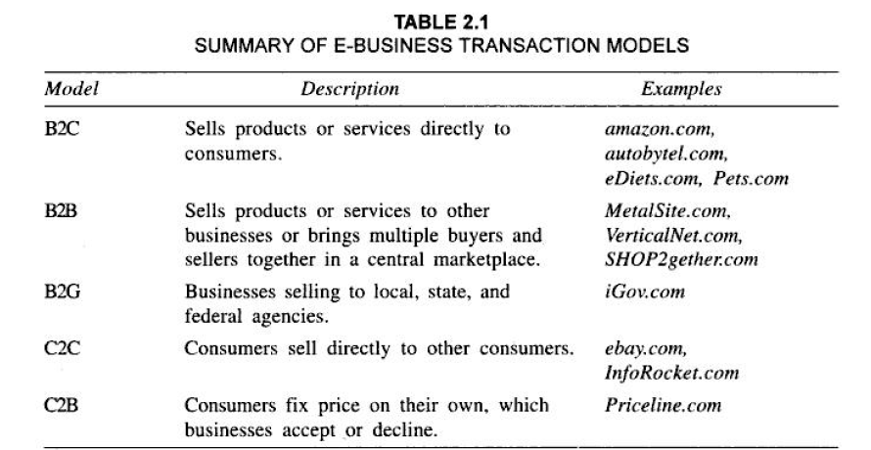

Business - to - Business (B2B)

Website following B2B business model sells its product to an intermediate buyer who then sells the product to the final customer. As an example, a wholesaler places an order from a company's website and after receiving the consignment, sells the end product to final customer who comes to buy the product at wholesaler's retail outlet.

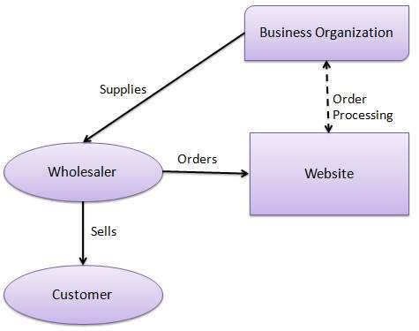

Business - to - Consumer(B2C)

Website following B2C business model sells its product directly to a customer. A customer can view products shown on the website of business organization. The customer can choose a product and order the same. Website will send a notification to the business organization via email and organization will dispatch the product/goods to the customer.

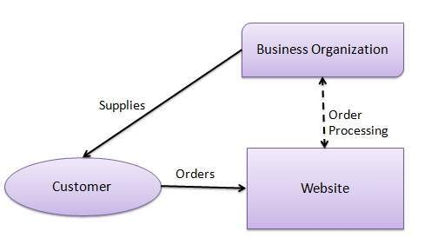

Example of

*excite.com, women.com, amazon.com* and *yahoo.com.*

Consumer - to - Consumer (C2C)

Website following C2C business model helps consumer to sell their assets like residential property, cars, motorcycles etc. or rent a room by publishing their information on the website. Website may or may not charge the consumer for its services. Another consumer may opt to buy the product of the first customer by viewing the post/advertisement on the website.

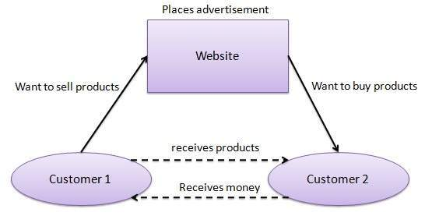

Consumer - to - Business (C2B)

In this model, a consumer approaches website showing multiple business organizations for a particular service. Consumer places an estimate of amount he/she wants to spend for a particular service. For example, comparison of interest rates of personal loan/ car loan provided by various banks via website. Business organization who fulfills the consumer's requirement within specified budget approaches the customer and provides its services.

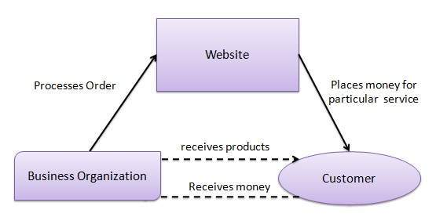

Business - to - Government (B2G)

B2G model is a variant of B2B model. Such websites are used by government to trade and exchange information with various business organizations. Such websites are accredited by the government and provide a medium to businesses to submit application forms to the government.

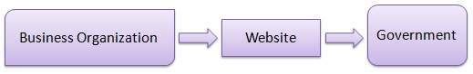

Government - to - Business (G2B)

Government uses B2G model website to approach business organizations. Such websites support auctions, tenders and application submission functionalities.

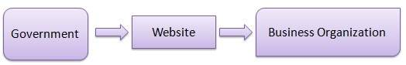

Government - to - Citizen (G2C)

Government uses G2C model website to approach citizen in general. Such websites support auctions of vehicles, machinery or any other material. Such website also provides services like registration for birth, marriage or death certificates. Main objectives of G2C website are to reduce average time for fulfilling people requests for various government services.

